Branching key challenge

Key learning points
- Living things can be grouped in different ways.
- When living things are grouped according to relatedness, a species is the smallest group living things can be divided into. (See Background science below)
- Each species is defined by specific key features.
- Not all members of a species are identical. There is variation.

Key words
Species – A type of closely related living things. E.g. 7-spot ladybirds are species of ladybird.
Variation – Differences between members of a group. E.g. Pet cats are all the same species, but they have different fur colours.
Features - A part or property of something that we can see or use our other senses to observe.

What to do
- Hand out cards for the variable ladybirds. (Card numbers xx - 11 to xx – 15)

- Students use their own key or use another group’s key to identify the ladybirds.

- Reveal which ladybird cards belong to which species.

- Students look at cards and identify similarities in each variable species.

- Reveal the shared features.

- Students re-work their keys to properly identify the variable species.

XX – 11 2-Spot ladybird  XX – 12 2-Spot ladybird  XX – 13 10-Spot ladybird  XX – 14 Harlequin ladybird  XX – 15 Harlequin ladybird | 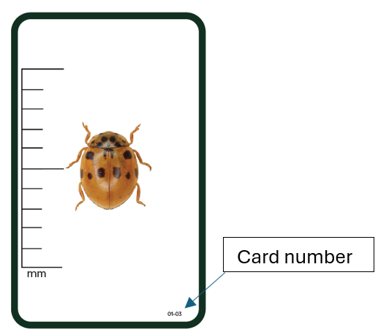

Extension
- Do a ladybird hunt or survey, and have students identify how many of each species they find using their re-worked keys.

- Use the concept cartoon to check students’ understanding.
The three images are all meadow grasshoppers. Their colouring is quite variable, but the lines on the sides of the thorax are almost parallel, and the wings do not have a white stripe. Therefore the 2nd response in the concept cartoon is technically correct. However the first response is also good as it demonstrates the key learning points.
Discussion demonstrating understanding of key learning points should include:
- The fact that there can be variation within a species. So being different colours doesn’t necessarily mean they are different grasshopper species.
- Similarities or differences in specific features. This shows awareness that they should be looking for key features rather than matching the whole animal.

Background Science
The aim of this activity is to demonstrate that there is variation within a species. With experience, scientists learn which features are less variable in each species and use these features for identification. In ladybirds, this is often a combination of size, leg colour, and pattern on the thorax (the segment just behind the head). Often scientists will need to use microscopes to inspect tiny features. Sometimes it isn’t possible to identify something just by looking at it. New technology has revealed that some organisms can look the same but have DNA sequences that are different enough to count as different species.
A species is the widest group with similar features and genes that can reproduce to make fertile offspring. Some species can be further split into smaller groups. For example, cultivars are varieties of a plant species which have a certain set of features, like being seedless or having a sweeter flavour, but can still reproduce normally with other members of the species. This can be seen in the grocery store when the packaging identifies the specific variety of fruit inside.
Subspecies are populations of a species which can be separated from the rest of the species for some reason. Often, this separation is caused by a geographic range or barrier. They can reproduce together successfully, but usually don’t because the populations are far apart and rarely come into contact with one another.

