Checking classification understanding
Are these grasshoppers the same species?
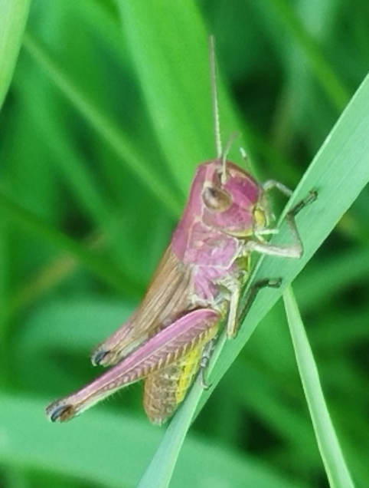
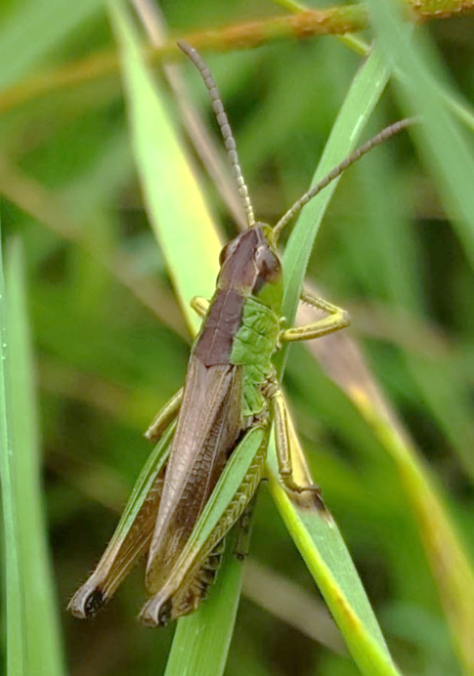
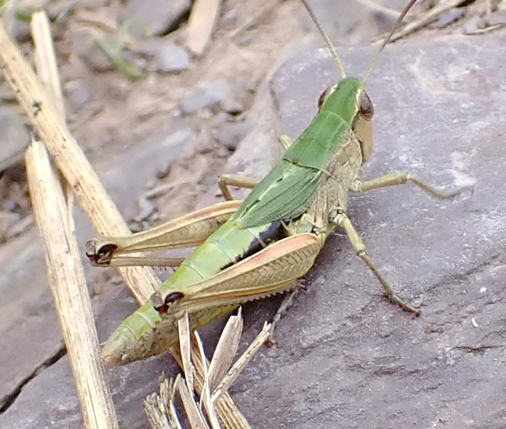

Yes. They are the same, they are just different colours.

No. These pictures don’t match, so they are different species.

I don’t know. I need to know what features are important for this species.

Explanation
The three images are all meadow grasshoppers. This species can be many different colours. However they all have lines on the sides of the thorax that are almost parallel, and their wings do not have a white stripe. The 2nd response in the concept cartoon is technically correct, but the first response demonstrates understanding of the key learning points.
Discussion demonstrating understanding of key learning points should include:
- The fact that there can be variation within a species. So, being different colours doesn’t necessarily mean they are different grasshopper species.

- Similarities or differences in specific features. This shows awareness that they should be looking for key features rather than matching the whole animal.

- If students have not been introduced to the different grasshopper species and their key characteristics, then concluding that they do not know because they don’t have enough information demonstrates students’ metacognitive thinking.

