Harlequin Ladybird Case Study

The case study demonstrates:
- Different ways of presenting information (table vs. bar charts).
- Why taking detailed notes can be important later on.

Case study source
Native ladybird decline caused by the invasive harlequin ladybird Harmonia axyridis: evidence from a long-term field study. Published 2018 in the Royal Entomological Society Journal of Insect Conservation and Diversity.
https://doi.org/10.1111/icad.12266

About the case study:
Researchers visited four sites nine times each year. Once per month in spring and autumn, twice in summer months. Researchers aimed to visit on warm, dry days as much as possible. At two sites, the ladybirds were collected from lime trees by holding a beating tray under the branches and tapping them so the insects fell into the tray. At one site, they used a beating tray to collect insects from pine trees. At the fourth site, they used sweep nets to collect insects from nettle plants.
Site(s)
Worlington; Fordham | Chippenham Fen | Chettisham
Lime  Tilia x europaea | Pine  Pinus sylvestris | Stinging nettle  Urtica dioica
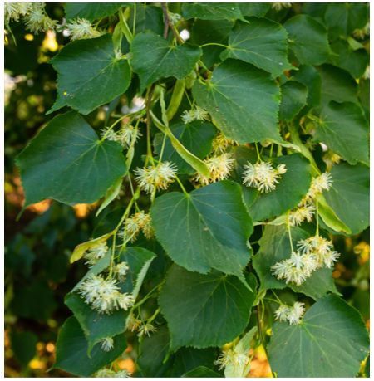 | 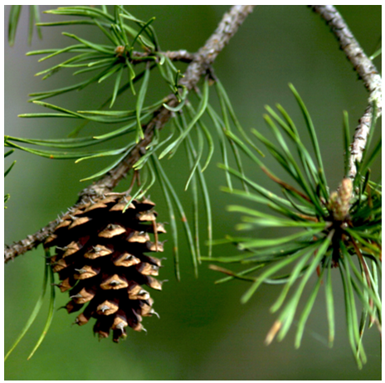 | 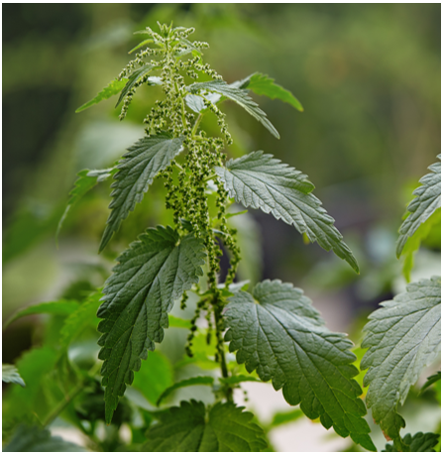
To simplify the data, only 2 sites are presented in the slides, but there was a roughly similar pattern between the 2 sites with lime trees, and the pine and nettle sites were different from the lime trees, with the harlequin ladybirds not dominating the habitat.
The full data table from the paper is also available in the accompanying spreadsheet.

About the data
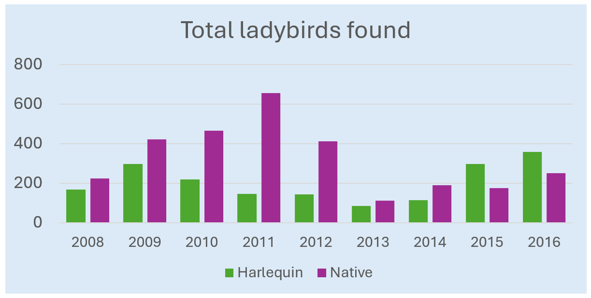
The data show a sudden drop in ladybird populations in 2013. There are several factors that may be contributing to this.
The scientists also noted that lime trees in one area were pollarded in 2013. Pollarding is a tree maintenance technique where the upper branches are removed. This helps the tree live longer. It can also prevent damage in strong winds because they have fewer heavy branches and offers less wind resistance. Pollarding would likely also mean fewer places for ladybirds to find food and hide. This may explain the drop in ladybird populations at the sites with lime trees, but not the other sites where there was no pollarding.
Weather conditions would likely affect all 4 sites in a similar way. 2012 was the second wettest year on record. This might have made it harder for ladybirds to find food and lay eggs. Then, early 2013 was particularly cold and snowy. This may have killed a greater proportion of ladybirds as they were hibernating through winter.

Results of the study
The researchers found that harlequin ladybirds became the most common ladybirds on lime trees. The researchers also found a negative correlation between harlequin ladybirds and 2-spot ladybirds. This means that as harlequin populations increased, the numbers of 2-spot ladybirds decreased. They hypothesise that the harlequins were predating (hunting and eating) the 2-spot ladybirds.
The researchers also hypothesize that the harlequin ladybird numbers might have been lower at the sites with pine trees because of competition with ladybirds that specialise in living and hunting in pine trees. Similarly, at the site with nettle plants, they may have struggled to compete with 7-spot ladybirds because there tend to be more of them on low leafy plants than in trees.

