Making a branching key

Key learning points
- The process of grouping living things based on their similarities and differences is called classification.
- You can use a classification key to help decide which group something belongs to.
- In science it is important to be specific and use appropriate language to record observations so other scientists understand what you mean.

Key words
Classification key - Diagrams which help us identify objects using yes/no questions.
Identify - To name something correctly.
Yes/no questions - A yes/no question is a type of sentence that asks something and is answered with only yes or no.
Features - A part or property of something that we can see or use our other senses to observe.

What to do
- Divide the class into groups/pairs.
- Give each group a set of ladybird species cards, numbers xx-01 to xx-10.
- Spread out the ladybird cards and look at their features.
- Think of some questions that will give the answer ‘yes’ for some ladybirds, and ‘no’ for the rest. Write down your questions on pieces of paper.
- Pick a question to be at the top. Draw arrows to show where the 'yes' and 'no' ladybirds should go.
- Add another question at the end of each arrow to split the ladybirds into smaller groups until each ladybird species ends up in its own spot on the page.
- Swap your key with another group and see if it works for their ladybirds.

Extension

- Use the sorting cards to play ladybird Snap or Concentration.
Use two sets of cards and arrange them face-down text to one another. Match pairs of ladybirds, one from each set. For an easier game use only card numbers xx–01 to xx-10.
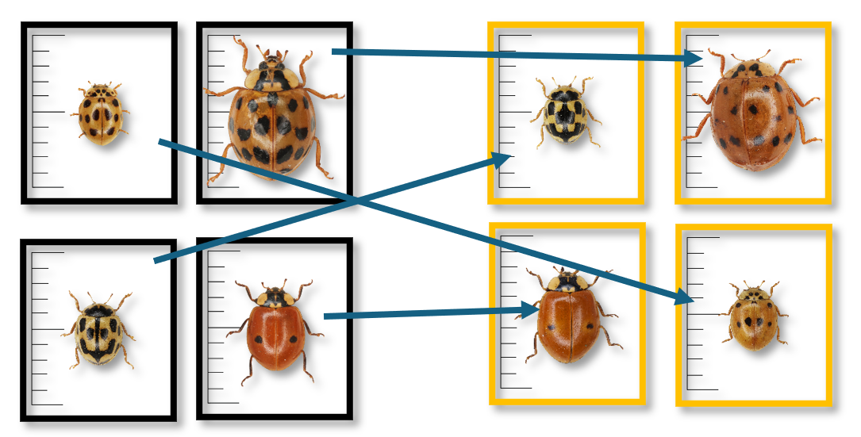

For a challenge, use all 15 cards and match by species. Students will need to look for the key features of each species and not be distracted by the elytra pattern in the more variable species. The example below shows matching species despite variability in pattern. In this case 10-spot ladybirds.
